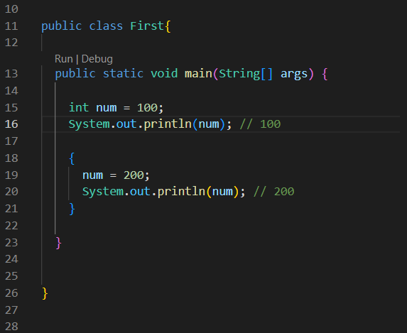

here at line 15 num is declared and initialized.

So now it will have functional block scope

But after line 18 another block scope begins

So within this new block the num is reinitialized at line 19

**So the previous initialization num = 100, will be now shadowed after line 19, but it is not shadowed till line 19**

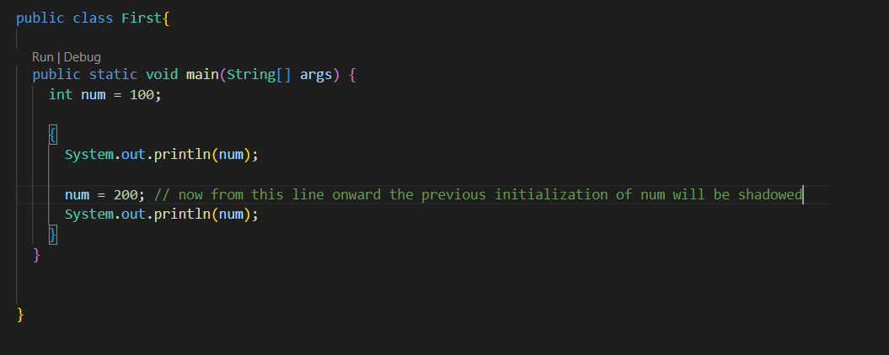

**Also in Java we can not redeclare the same variable inside the same scope, but we can reinitialize**

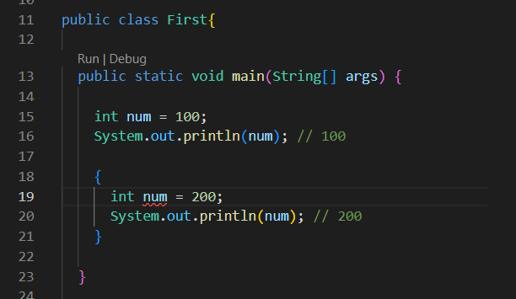

here num is decalred and initialized first at line 15

and again we try to redeclare in line 19, which is not allowed

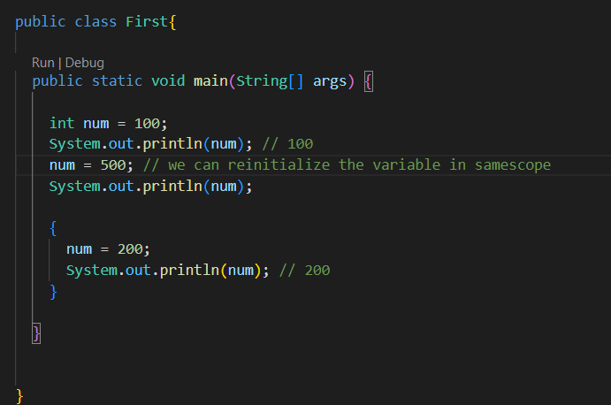

**Things are little bit different for class variables**

It seems like class variables can be redeclared inside the function or block scope of the same class

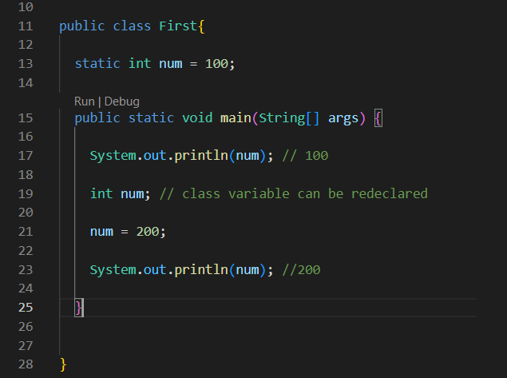

Also the shadowing occurs after the declaration not initialization

Here after the line 19, the previous value of num = 100, is shadowed

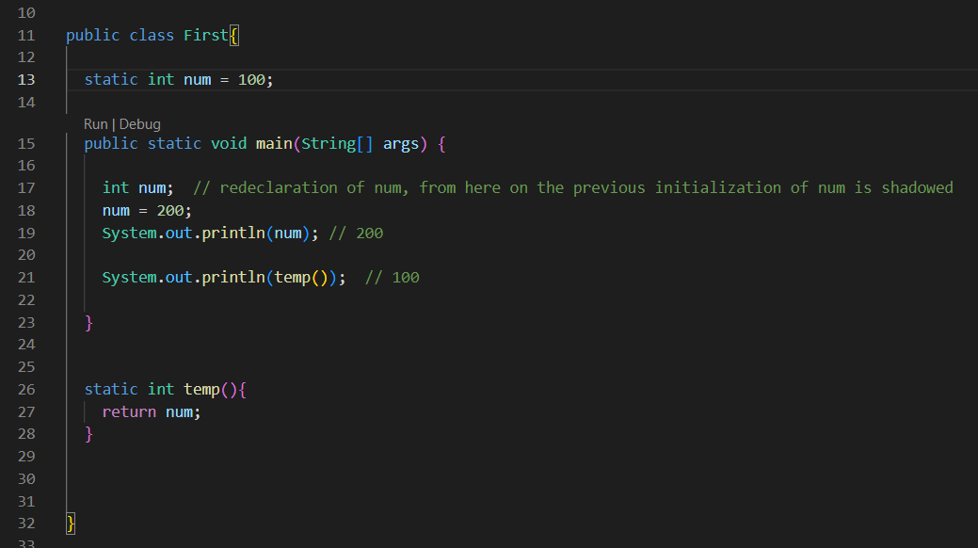

Also the redeclaration and reinitialization of num had occurred inside the main function not inside the temp function

So the temp function being inside the scope of First class will work on the

int num = 100;